Лабораторная работ 14
Exercise 1 - Trend Report Bookmark this page Let's do some trend analysis.
First, let's show a chart to compare total sales and total units by year. And then let's show two more charts showing the variances in total sales and total units over the years.
1. If it is not already open, open the Lab 3 - Starting.pbix file.
2. Create a new report page by clicking the New Page icon at the bottom of the report view. 3. Drag the Year field from the Date table to the report and create the first plot.
4. Drag the fields Total Sales and Total Units from the Sales table onto the Year chart.
5. Modify the chart to use line and column chart visualization.
6. Verify that Year is shown as General Axis, Total Sales as Column Values, and Total Units as Row Values ​​in the visualization details.
7. Create a second chart based on the Waterfall Chart visualization.
8. Drag the Sales Var field from the Sales table to the Sales Var chart.
9. Drag the Year field from the Date table to the Sales Var chart.
10. Create a third chart, also based on the Waterfall Chart visualization.
11. Drag the Total Units field from the Sales table to the Total Units graph.
12. Drag the Year field from the Date table to the Total Units chart.
13. Click the Elipse button on the Sales Var and Total Units Var graphs and sort ascending by year.
14. Add a text box to the report and enter the annual trend as text.
15. Rename the report sheet to Yearly Trend.
16. Click Save to save the Power BI file.
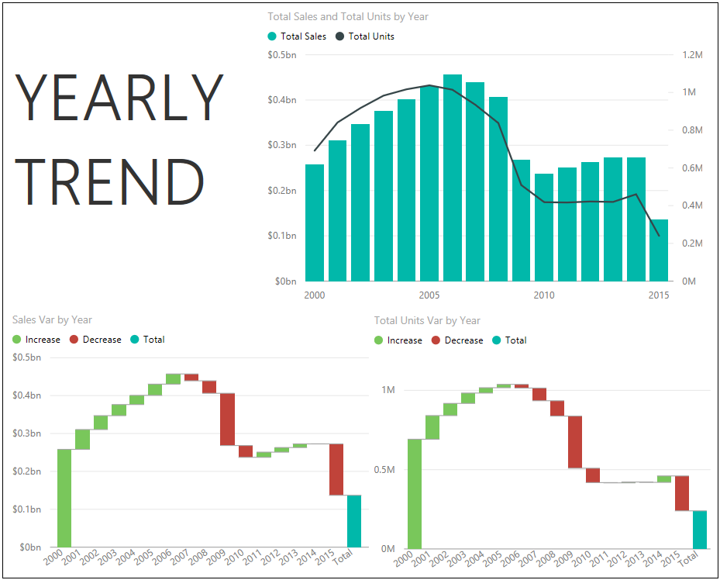
Exercise 2 - Rank Report Bookmark this page Now you want to analyze sales of individual products (revenue) and volume (units).
You decide to show this using two histograms.
1. If it is not already open, open the Lab 3 - Starting.pbix file.
2. Create a new report page by clicking the New Page icon at the bottom of the report view. 3. Drag the Total Sales field from the Sales table to the report and create a chart.
4. Drag the Product field from the Products table onto the graph.
5. Modify the chart to use the stacked column chart visualization.
6. Make sure the chart is sorted by total sales.
7. Drag the Total Units field from the Sales table to the report and create a new chart.
8. Drag the Product field from the Products table onto the graph.
9. Modify the chart to use the stacked column chart visualization.
10. Make sure the chart is sorted by total units.
11. Drag the Year field from the Date table to the report and create a new chart.
12. Modify the chart to use the slicer visualization.
13. Change the slicer type by clicking the drop-down arrow on the year chart and selecting the List option.
14. Add a text box to the report and enter Top Products as the text.
15. Rename the report sheet to Top Products.
16. Click Save to save the Power BI file.
